Michael Julien

Binary code is more abstract than swift code because swift code is easier to use with the English language.



Swift code is more abstract than block code because you need to be able to code whereas in block code its click and drag.

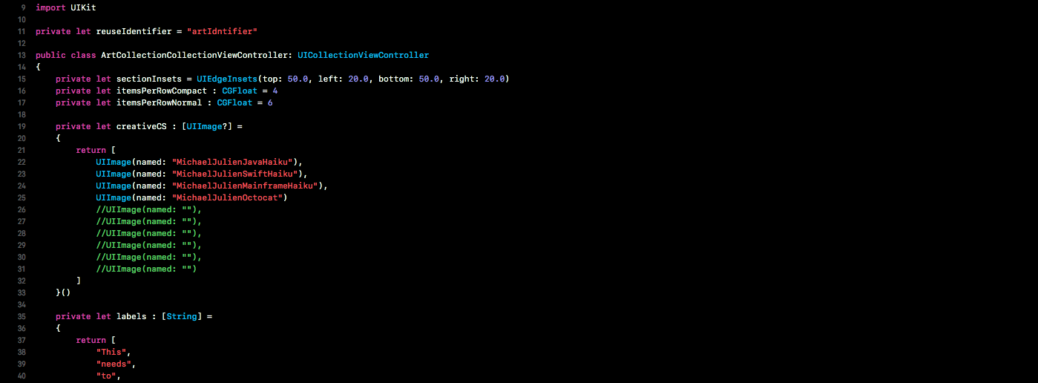

Block code is less abstract than swift code because it is the easiest to use with the English language and does not require you to write actual code. 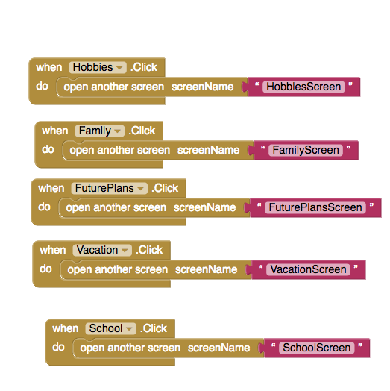

Byte code is the most abstract because only the computer can understand the code that is there.

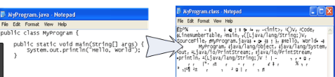

Logic gates are more abstract than block code and swift code because it uses a different type of language using symbols to represent if, or, and “and”.